Windows Movie Maker Instructions
STEP ONE: Importing video
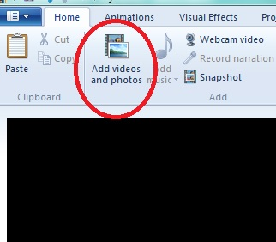
To start, click on “Add Videos and Photos” in the upper left hand corner of the screen. This will pop up another window. Navigate to the videos or pictures you would like to add. You can select multiple video files by holding down the ctrl button and then selecting the videos.

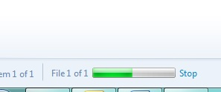
Once the videos are selected, click “Open.” The videos will then begin to load into the video editor. The loading time will vary depending on the size of the video. You can watch the progress in the lower left hand corner.

STEP TWO: Moving video around, and other basic tools
If your video are not in the correct order, just click and drag the videos in the order you would like them to be.
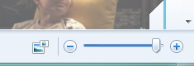
To make the preview screen bigger or smaller, just select the line separating the two and you can drag it to make the preview screen different sizes.
To zoom in and out on the “timeline,” use the plus and minus sign in the lower right hand corner.
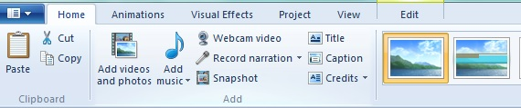
In the navigation tab, you will see many different features to editing your video you will navigate between.

STEP THREE: Video editing tools
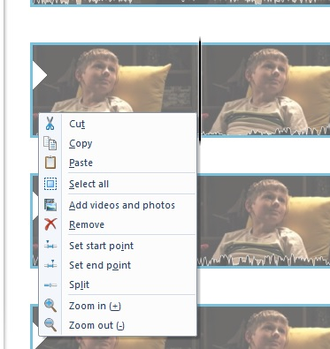
To begin, lets learn how to split your clips. Just drag your cursor to the place you would like to split the video clip.
Then right click and a new menu will pop up. Select “Split,” and you will see the video clip split into two different clips.

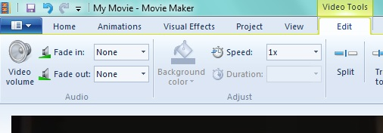
Next, lets learn how to control volume of your clip and other video tools. Click on the yellow tab up at the top that says “Video Tools.” From there, you can control the video volume, if the video volume fades in and out, how fast the clips goes (you can put it in fast forward or slow-mo), and there’s the option to split clips from this menu as well.
STEP FOUR: Adding titles and clips
The first thing you can to do is make sure all of your video editing is done FIRST. When you edit a video after you have inserted any captions, the captions don’t move. Because of this, you want to make sure all your video editing first and THEN add titles, captions, and credits.
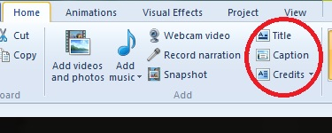
First, navigate to the “Home” tab and then you will see the three options you have: Title, Caption, and Credits. “Title” will create a title slide before or after a clips. “Caption” will create a caption on top of a video clip. “Credits” will create credits that will scroll at the end of your video.
All three essential work the same. Let’s start with “Title.” When you select this, a new screen will pop up. In the preview screen, just click on “My Title,” which is what the text defaults to. From there, you will be able to type in your title. You will also be able to move the text wherever you would like on the screen. Up at the top menu, you can control what font, color, justification, font size, etc. that you title will be. You can also choose the background color for your title slide. The title slide will default to being 7 seconds long. You can change the length through the “Text duration.”
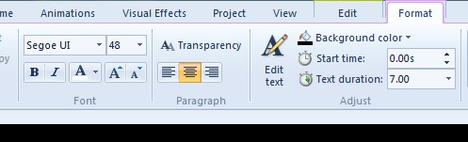

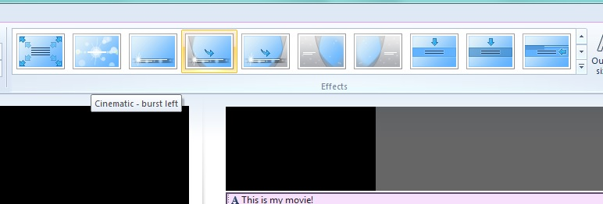
In another section of the top menu, you can control what animation the title slide takes. Just hover your mouse over one of them for a quick preview. Click on it to select it.

If you find that the title adds itself into the wrong section of your timeline, you just need to click and drag the title to the correct placement.
“Captions” work in a very similar way with the text tools and styles of animation. However, since the captions are on the video, there are a few other options you need to consider.
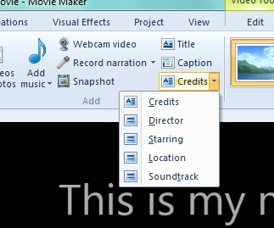
First, place your cursor on the timeline where you would like the captions to begin. Then click “Caption” from the top menu. (Remember, you need to be on the “Home” tab.) A similar menu will pop up. You will use the same editing tools as the title to edit your captions.
The last option is “Credits.” Credits will automatically be added to the end of your timeline. You can either put all of your credits in one slide or you can divide it out by “Director,” “Cast,” etc. by clicking the arrow on the left of the credits button. This will create different title slides for each of the different catagories.

STEP FIVE: Adding music or narration
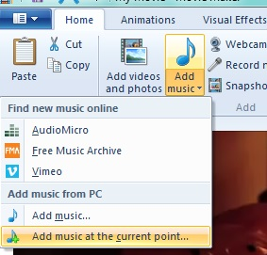
To add music to your movie, place your cursor where you would like the music to start. The select the ARROW below “Add music.” The select “Add music at the current point.”
If you don’t do this, your music will automatically insert at the beginning of the movie.
From here, a menu will pop up and you can navigate to where your music is.
Your music will appear as a green bar below your video.
To edit the music, click on the green tab at the top that says “Music Tools.”
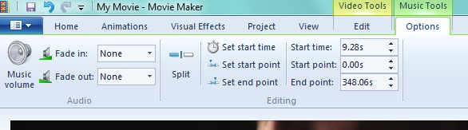

From this menu, you can control the music volume, if it fades in and out, a few other features.
“Start time” is where you would like you would like the music to start in the video.
“Start point” is the point in the music you would like it to start. (For example, maybe you would like the music track to start 10 seconds into the track as opposed to at the beginning of the track.)
“End point” is when you would like the music to start.
The “Set start time” “Set start point,” and “Set end point” make it easy for you to set exactly where you would like things to be. All you have to do is place your curser on the timeline where you would like that point to be and then press either one of these buttons. You will see the numbers on the right will automatically change.
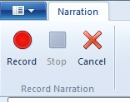
To record narration, first make sure your microphone is plugged in. Then place your cursor where you would like to record narration. Then from the “Home” tab, click “Record Narration.” From the menu that pops up, just click “Record” to start recording. Then “Stop” to finish the recording. The narration will insert automatically below the video in brown. From the “Narration Tools” menu at the top, you can edit the narration just like the music.
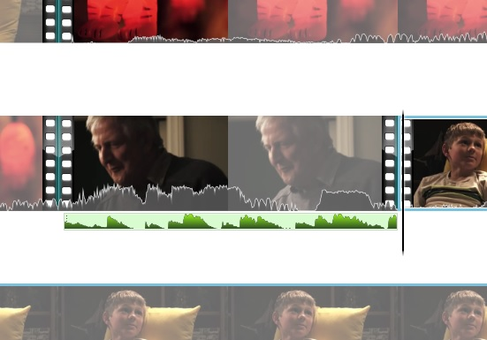
To balance the volume between the narration or music and the video, first split the video clip at the beginning of the narration or music and at the end. It should look something like this.
<---------------------------------

From here, click on the “Video tools” and then “Video Volume” to edit the volume of the video. Click on “Music tools” and then “Music Volume” to edit the volume of the music. Work to find the right balance between the two.
STEP SIX: Saving your movie
Remember, there are TWO different ways to save your movie.
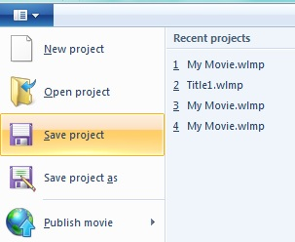
The first way is to save it as a project file. The project file is the way that you save it if you are not finished and need to come back to continue editing. This is NOT the way to hand it into your teacher!! This is just a way to save it so you can continue to work on it. To save it as a project file, just go to the menu in the upper left hand corner and then go to “Save Project.” A menu will pop up for you to name your file and decide where you want to save it.

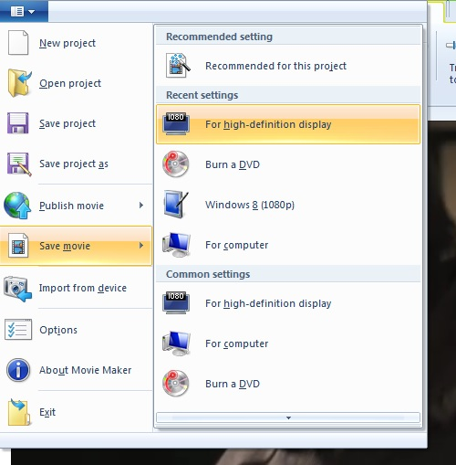
The other way to save your project is to render your video and save it as a movie, NOT a project. This IS the way to hand it into your teacher! This way, the movie renders as a whole video for your teachers to watch. To save it as a movie file, just go to the menu in the upper left hand corner and then go to “Save Movie.” Then go to “For high definition display.
A menu will pop up for you to name your file and decide where you want to save it. The movie will then begin to render. Please realize it may take a few minute for the movie to render. Give yourself time.

You are done! Congratulations! You’ve made a movie!

